(Approx. 954 words)

Bluetooth Adapters – Do I need one?
By Phil Sorrentino, Secretary and APCUG Rep, Sun City Center Computer Club
https://scccomputerclub.org/
philsorr (at) yahoo.com

The short answer is no if all your devices have Bluetooth incorporated in them, but yes, if you have a non-Bluetooth device that you would like to use with other Bluetooth devices. A Bluetooth adapter allows a non-Bluetooth device to work with a Bluetooth device. The adapter does this by providing Bluetooth electronics for the non-Bluetooth device. Bluetooth is a wireless communications standard for interconnecting electronic devices. It allows devices to connect wirelessly over a range of about 100 ft. This wireless connection can be beneficial if devices are in separate rooms in a house. But that's the technical side of Bluetooth. Most of us know Bluetooth as how our smartphones connect to the radio system in our cars to provide "hands-free" phone conversations. This is probably one of the most extensive uses of Bluetooth today, but there are other uses. Two other uses of Bluetooth that come to mind involve listening to music; wireless headphones or earbuds and wireless (Bluetooth) speakers.
As implied above, Bluetooth is included in Apple and Android smartphones. Bluetooth is a convenient way to connect a smartphone to a listening device like headphones or a speaker. (In fact, some smartphones like the Apple iPhone XS, the Google Pixel 3, and the Motorola Moto Z3 don't even have a 3.5 mm wired headphone jack, making Bluetooth the only way to connect these devices to headphones.) Headphones are a convenient way to take advantage of a smartphone being used as a music player. Start the phone's music app, put on the headphones, and enjoy the music. Apple wireless headphones are very noticeable. Apple AirPods, as they are called, are typically white and look like someone cut the wires going to each individual headphone. Besides Apple, many other wireless headphones are available from Sony, Bose, LG, Jaybird, Optoma, Beats, and others. Using Bluetooth headphones, you replace the wires needed with standard headphones with the wireless Bluetooth connection. That way, no wires are going from your head to your phone, which might be in your hand or in your pocket, which might get in your way. (With some of these wireless headphones, there is still a wire going from one headphone to the other that usually goes behind the head.)
Bluetooth Speakers - the other use for Bluetooth. Speakers that have Bluetooth included are sold as Bluetooth or Smart Speakers. There are many of these available from Sony, JBL, Sonos, Bose, and others. Most of these speakers are powered by batteries, so they are portable, and you can use them anywhere. Many are waterproof, encouraging their use at the beach or around the pool. These speakers contain Bluetooth electronics, which allow them to connect to a device such as a smartphone or a computer and be used in place of the speaker(s) on the device to provide the sound. So, if a Bluetooth speaker is connected to a smartphone and a music player app on the smartphone is started, the music will be heard on the Bluetooth speaker. A Bluetooth speaker is usually much more powerful than the small speaker on the smartphone, and the quality of the Bluetooth speaker is typically much better than that of the smartphone speaker, so the listening experience may be more enjoyable. And if the Bluetooth speaker is powerful enough, it may even be used to fill a large room and entertain many people.
Wireless headphones and Bluetooth speakers are quite helpful when used with a smartphone or a computer with Bluetooth electronics embedded, but what about those devices that don't have Bluetooth electronics included, like an older stereo receiver or a radio? Well, this is where Bluetooth adapters come into play. Bluetooth adapters allow you to listen to your non-Bluetooth stereo or radio using your wireless headphones or Bluetooth speakers. The adapter provides the Bluetooth electronics needed to connect to other Bluetooth devices. Bluetooth adapters from Logitech, Taotronics, Trond, 1Mii, and others should cost less than $50. Except for the inexpensive items, most adapters can be used as a Bluetooth Transmitter or a Bluetooth Receiver. When the adapter is used with a non-Bluetooth source of audio (like a stereo), it is being used as a Transmitter. When the adapter is used with a non-Bluetooth device that receives the audio (like a powered speaker), it is being used as a Receiver. Adapters are powered by wall power or battery, or both. If your stereo is not portable, you probably don't need a portable adapter. (Be aware that some less expensive portable Bluetooth adapters cannot charge their battery and operate as a transmitter at the same time.)
Setting up the adapter to function as a transmitter is pretty straightforward. First, the audio output from your non-Bluetooth stereo gets connected to the adapter's input, typically with a 3.5 mm stereo cable. (Some more expensive adapters even support optical audio.) Then when you go through the pairing and connecting process, the audio from the non-Bluetooth stereo will be audible in the wireless Bluetooth headphones. (In the diagram, a Bluetooth speaker can be substituted for the headphones, and you would have audio as loud as the particular speaker could provide.)
Bluetooth Adapter used as a Transmitter
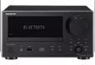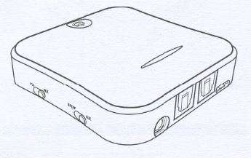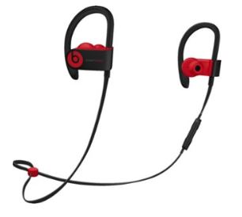
Non-Bluetooth Stereo Bluetooth Adapter Bluetooth Headphones

Many adapters can also allow a non-Bluetooth device to operate with a Bluetooth audio device as the audio source. In this arrangement, the adapter is used as a Receiver. The non-Bluetooth device receives the audio from a Bluetooth device via the Bluetooth Adapter used in the Receive mode, as shown in the following.
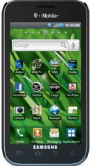
Bluetooth Device Bluetooth Adapter Non-Bluetooth Stereo
So now, do you need a Bluetooth Adapter?

